MERIDIAN RESOURCES TRANSITION READINESS SURVEY

Thank you for taking our confidential Transition Readiness Survey. The survey will take approximately 10 minutes to complete. In order for the Meridian program to be of maximum value to you, it is important to take a moment to identify your career transition needs and to establish clear expectations regarding how Meridian and your personal coach will help you attain your goals.
Return your survey to your coach as soon as possible.

Name Coach

The Coaching Relationship
A solid and active partnership between you and your Meridian coach is essential to your success. Confidentiality is a key component of this relationship. We do report progress to your former company in the form of basic services we have provided in the process with no narratives. We never share specifics of your search or your new opportunity.
Your Meridian Coach commits to providing you with exceptional service and solid advice in phases of your transition - until you meet your goal. There are no time limits on your program. Your coach will contact you on a regular or agreed-upon basis to provide assistance and support for the duration of your program. Your coach offers you expanded accessibility, including evenings, weekends, and holidays when necessary. Your coach is committed to keeping you on track and helping you maintain focus and momentum.

Please read the “What is Coaching?” document provided in your Welcome Email.

I have read the “What is Coaching” document and I understand my Meridian Coach's commitment to my career transition.

Comments or questions?
As an active participant in your Meridian program, you can do your part by committing to the partnership as well. We ask that you work constructively with your Coach toward mutual objectives and complete assignments in a timely manner. With decades of business and Career Transition Coaching experience, we offer you the most current strategic advice in all elements of your search process. All we ask is that you actively listen to our feedback and advice and consider incorporating our suggestions into your campaign; an active line of communication between you and your Coach is essential. We ask that you regularly communicate with your coach regarding your concerns and progress, and most certainly let us know when you have successfully met your goal.

I understand the importance of my commitment to the coaching relationship.

Program Benefits and Features
Meridian provides information packets that detail the benefits and features of your program.
Prior to enrollment, you may have received an information packet from your former employer or a Meridian Representative.

I reviewed by information packet and understand my program benefits.

I understand the role of Meridian as my career transition service provider and how that is different from working with recruiters and search firms.

Managing Change
A change event triggers a transition process. When change occurs it makes today feel significantly and permanently different from yesterday. Transition is the mental, emotional, and psychological process that we go through over time to absorb and adapt to the event. While a change event is visible to others, with a clear "before" and "after" the transition process is not clearly observable by others. It is a very personal experience. How you respond to the change in your transition will be unique to you and will take into account many factors, such as your emotional attachment to the way things were and how the change impacts those closest to you.

Below is a transition curve that represents the variety of emotions you may experience throughout the process. What emotions are you feeling at this point? Discuss with your coach.
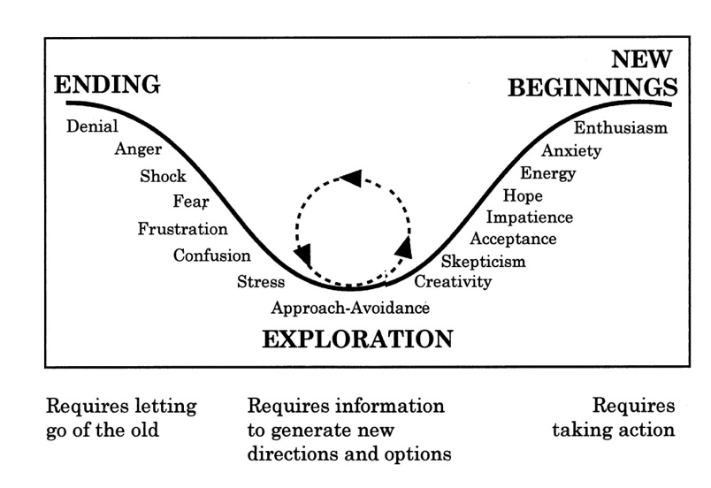
I understand that change is a process and my coach will play a role in helping me navigate it successfully.

I will actively partner with my coach to help reach my goals.

I will stay in regular contact with my coach for guidance, support, and motivation.

I am willing to accept coaching and take action on suggestions.

I have the ability to look ahead and move beyond the circumstances that led to the transition.

I have a positive outlook on what the future may hold.

I have a strong personal support system (friends, family, associations) to help me in this process.

My financial situation is healthy enough to carry me to the next opportunity.

Comments or concerns regarding managing change:

Personal and Career Assessment
Personal and Career Assessment is a process that will help you identify viable career options based on a process of self-discovery to define key strengths, personal attributes, and experiences that can be offered in your next career opportunity. Consider the following statements and identify areas where Meridian may be of value to you.

I need help me defining my personal values and goals for relevant opportunities.

I need help identifying the types of targeted opportunities that would be best to pursue.

I need help defining specific criteria needed to assess my targeted companies and potential opportunities (personal values, likes/dislikes in a career opportunity, geographic location, company size, etc.).

I need help identifying my career accomplishments and how to effectively articulate them.

Comments or concerns regarding personal and career assessment:

Job Search Readiness
Job Search Readiness is a process of developing key marketing components necessary for the career search campaign. Please consider the following statements and identify areas where Meridian can be of value to you.

I would like my coach to help me review or create a resume that effectively presents my skills, experiences, education, and career accomplishments toward my desired transition goals.

I need help ensuring my resume is visually appealing and easy-to-follow.

I need help ensuring my resume is formatted properly for online application tracking systems.

I need help ensuring my LinkedIn profile is complete and set up to optimize views from my network and recruiters.

I need to understand how to use LinkedIn in my overall job search strategy.

I need help crafting cover letters and email messaging for my search.

Comments or concerns regarding job search readiness:

Launching an Effective Job Search Campaign
Launching an Effective Job Search Campaign is where the work really begins. This is the creation and implementation of your action plan. How effective you are in this segment of your transition will translate into how quickly you secure your next new opportunity. Please consider the following statements and identify areas where Meridian can be of value.

I need help understanding the concept of networking for a job search.

I need help understanding how to best approach people I already know for help with my job search.

I need help understanding how to best approach people I do not know for help with my job search.

I need help setting appropriate transition goals and developing / implementing a strategic action plan.

Comments or concerns regarding launching an effective job search campaign:

Interviewing Skills
Interviewing Skills showcase your ability to convey a solid, professional image through verbal and face-to-face communications. Please consider the following statements and identify areas where Meridian can be of value and support to you.

I need help effectively and appropriately explaining why I am in transition.

I need help preparing a compelling introduction of myself so that I may effectively answer the question, "Tell me a little about yourself, and what are you looking for?"

I need tips and strategies for presenting myself in virtual interviews.

I am interested in understanding different types of interviews, working on responses to questions, and doing mock interviews with my coach.

I would like my coach to guide me through handling objections, rejection, and recovering quickly from setbacks.

I would like my coach to serve as a sounding-board to help me evaluate offers and negotiate effectively.

Comments or concerns regarding interview skills:

Additional Information
You may have other concerns that you wish to discuss with your Coach. Perhaps the following considerations may be helpful to organize your thoughts.

What are your key concerns regarding your career transition?

Are there any obstacles you foresee in your transition such as age, education, experience, salary, or relocation?

How is your current or targeted industry and/or job function faring in today’s market?

How many months do you realistically think you will be in transition?

Other items you wish to discuss with your coach.

Thank you for completing this survey. Please send a copy to your coach prior to your next session so they may be prepared to discuss your questions and concerns.

